ASSESMENT TOOL – 01
Q1. Explain Schema and Instance with examples. Distinguish between Logical Schema, Physical Schema, and View Schema.
1. Schema
A Schema is the overall structure or blueprint of a database. It defines how the data is organized, including tables, attributes, relationships, and constraints. A schema is designed before data is entered and changes very rarely.
Example:
Student_ID | Name | Department | CGPA

This table structure is called the Schema.

2. Instance
An Instance is the actual data stored in the database at a particular point in time. Unlike the schema, the instance changes whenever records are added, updated, or deleted.
Example:
Student_ID | Name | Department | CGPA
101 | Kadhir | CSE | 8.9
102 | Rahul | ECE | 8.5

These records represent the Instance of the database.

Difference Between Schema and Instance
Schema | Instance
Blueprint or structure of the database | Actual data stored in the database
Changes very rarely | Changes frequently
Defined during database design | Changes whenever data is inserted, updated, or deleted
Describes tables, attributes, and relationships | Contains the current values of the records

Types of Schema
1. Logical Schema
The Logical Schema describes the logical structure of the entire database. It defines tables, attributes, relationships, and constraints without considering how the data is physically stored.
Example:
STUDENT (Student_ID, Name, Department, CGPA)
2. Physical Schema
The Physical Schema describes how the data is physically stored in the storage device. It includes storage details such as file organization, indexes, and access methods.
Example:
The Student table is stored in files on the hard disk using B+ Tree indexing.
3. View Schema
The View Schema (External Schema) defines what a particular user can see from the database. Different users can have different views based on their access permissions.
Example:
A faculty member can view:
Student_ID, Name & CGPA

A student can view only:
Student_ID & Name
Difference Between Logical Schema, Physical Schema, and View Schema
Logical Schema | Physical Schema | View Schema
Defines the logical structure of the database | Defines how data is physically stored | Defines what a specific user can see
Includes tables, attributes, and relationships | Includes storage methods, indexes, and files | Includes only required data for users
Independent of physical storage | Depends on storage devices | Depends on user requirements
Used by database designers | Used by system/database administrators | Used by end users and applications

Conclusion
- Schema is the blueprint of the database, while Instance is the actual data stored at a particular time.
- A database has three types of schemas:
  - Logical Schema – Defines the database structure.
  - Physical Schema – Defines how data is stored.
  - View Schema – Defines what users are allowed to see.

Q2. Identify the entities, attributes, and relationships for a Bank Management System and construct its ER diagram.
Answer
Introduction
A Bank Management System stores and manages information about customers, accounts, branches, employees, and loans. An Entity-Relationship (ER) Diagram represents these entities, their attributes, and the relationships among them.
1. Entities and Attributes
Customer
- Customer_ID (Primary Key)
- Name
- Address
- Phone_Number
- Email
Account
- Account_No (Primary Key)
- Account_Type
- Balance
- Opening_Date
Branch
- Branch_ID (Primary Key)
- Branch_Name
- Location

Employee
- Employee_ID (Primary Key)
- Name
- Designation
- Salary
Loan
- Loan_ID (Primary Key)
- Loan_Type
- Loan_Amount
2. Relationships
- A Customer owns one or more Accounts.
- An Account belongs to one Branch.
- A Branch employs many Employees.
- A Customer can apply for one or more Loans.
3. ER Diagram
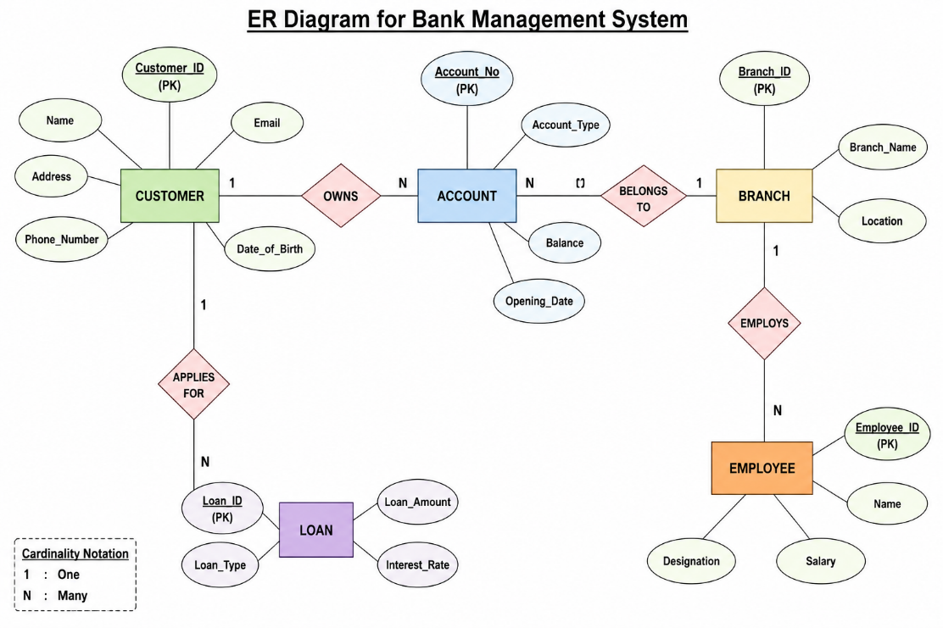

Conclusion
The ER diagram represents the major entities, their attributes, and the relationships in a Bank Management System, making database design simple and organized.

Q3. Explain the Extended ER (EER) model. Describe the concepts of generalization, specialization, and aggregation.
Answer
Extended ER (EER) Model
The Extended Entity-Relationship (EER) Model is an advanced version of the ER model. It includes additional concepts such as generalization, specialization, inheritance, and aggregation, making it suitable for modeling complex real-world databases.
1. Generalization
Definition
Generalization is the process of combining two or more lower-level entities into a higher-level entity based on common features.
Example
Doctor and Patient are generalized into Person.
2. Specialization
Definition
Specialization is the process of dividing one higher-level entity into smaller specialized entities based on their characteristics.
Example:
Person is specialized into Doctor and Patient.

3. Aggregation
Definition
Aggregation is a technique where a relationship between entities is treated as a higher-level entity so it can participate in another relationship.
Example
Works_On is treated as an entity.

Conclusion:
The EER model improves the basic ER model by introducing inheritance and advanced relationships, making database design more flexible and realistic.
Q4. Design an EER diagram for a Hospital Management System incorporating inheritance and weak entities.
Answer
Introduction
A Hospital Management System stores information about doctors, patients, departments, rooms, and medical records. The EER model is used to represent inheritance and weak entities.
ENTITIES
Person
- Person_ID (PK)
- Name
- Age
- Gender

Doctor
- Doctor_ID
- Specialization
- Salary
Patient
- Patient_ID
- Disease
- Admission_Date
Department
- Department_ID
- Department_Name
Room
- Room_No
- Room_Type
Medical_Record (Weak Entity)
- Record_No
- Diagnosis
- Treatment

RELATIONSHIPS
- Doctor treats Patient.
- Doctor works in Department.
- Patient admitted to Room.
- Patient has Medical_Record.

Inheritance
Doctor and Patient inherit the common properties of Person.

Weak Entity
The Medical_Record cannot exist without a Patient, so it is a weak entity.

Complete EER Diagram
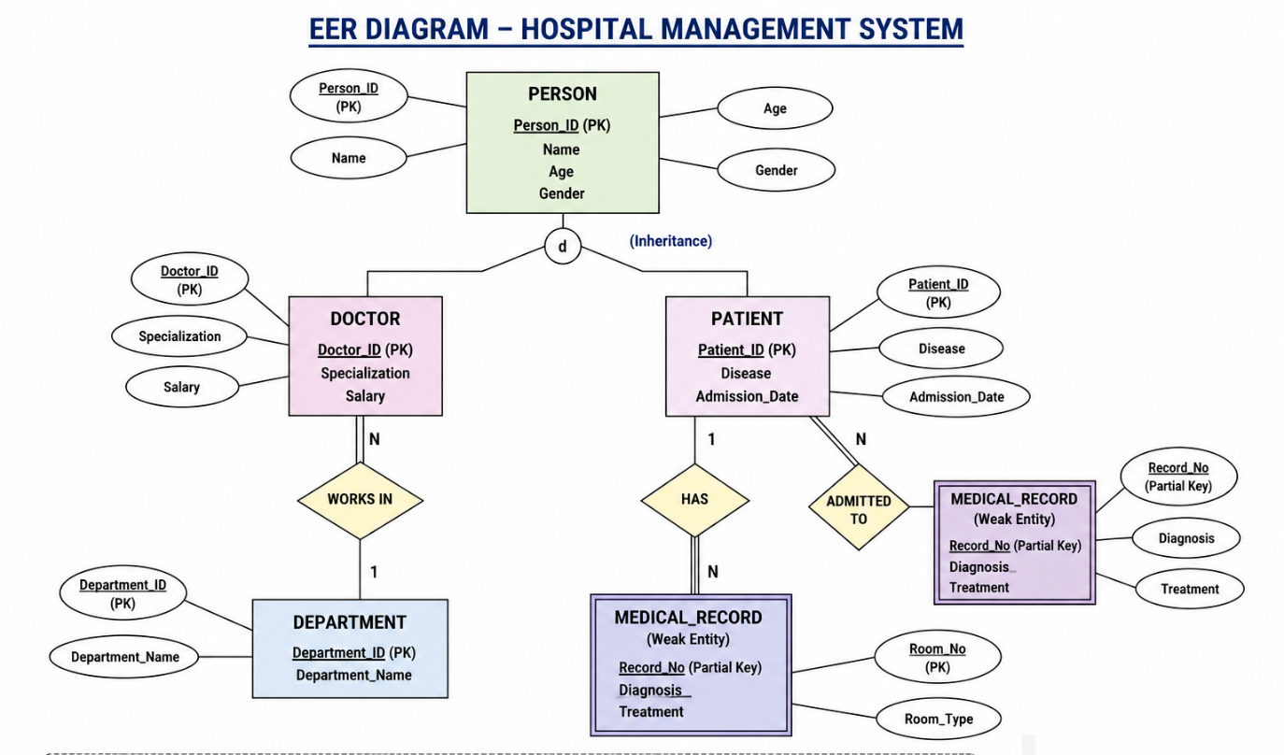

Conclusion
The Hospital Management System uses inheritance to avoid redundancy and weak entities to represent dependent data such as medical records.

Q5. Explain the role of a DBA (Database Administrator) and the responsibilities associated with the position.

Answer
Introduction
A Database Administrator (DBA) is a person responsible for the installation, configuration, maintenance, security, performance, and overall management of a database system. The DBA ensures that the database is available, secure, reliable, and performs efficiently for users and applications.
Role of a DBA
The primary role of a DBA is to manage the database system and ensure that data is stored securely, accessed efficiently, and recovered safely in case of failure. A DBA also monitors database performance and supports users in database-related activities.
Responsibilities of a DBA
1. Database Installation and Configuration
- Installs the Database Management System (DBMS) software.
- Configures database settings according to organizational requirements.
- Creates new databases and database environments.
2. Database Design
- Creates database schemas, tables, indexes, and relationships.
- Defines primary keys, foreign keys, and constraints.
- Ensures proper database normalization.
3. User Management
- Creates user accounts.
- Assigns roles and privileges.
- Grants and revokes user permissions.
- Prevents unauthorized access.

4. Database Security
- Protects confidential data from unauthorized users.
- Implements authentication and authorization mechanisms.
- Encrypts sensitive information.
- Regularly updates security policies.
5. Backup and Recovery
- Performs regular database backups.
- Restores lost or corrupted data.
- Develops disaster recovery plans.
- Ensures data availability after system failures.
6. Performance Monitoring and Tuning
- Monitors database performance continuously.
- Identifies slow queries.
- Optimizes SQL queries and indexes.
- Improves database response time.
7. Database Maintenance
- Updates database software.
- Installs patches and new versions.
- Removes unnecessary data.
- Maintains database consistency and reliability.

8. Data Integrity
- Ensures data is accurate and consistent.
- Enforces integrity constraints.
- Prevents duplicate and invalid data.
- Maintains data quality.
9. Storage Management
- Allocates storage space efficiently.
- Monitors disk usage.
- Expands storage when required.
- Maintains database files.
10. Troubleshooting
- Detects database errors.
- Resolves hardware and software issues.
- Fixes connectivity problems.
- Ensures uninterrupted database services.
11. Database Documentation
- Maintains documentation of database structures.
- Records backup schedules.
- Documents security policies and recovery procedures.
12. Supporting Developers and Users
- Assists developers in writing efficient SQL queries.
- Helps users solve database-related problems.
- Provides technical support and training.

Advantages of a DBA
- Ensures database security.
- Maintains data accuracy.
- Improves database performance.
- Prevents data loss.
- Supports multiple users.
- Increases system reliability.
- Reduces downtime.
- Ensures efficient data management.

Conclusion
A Database Administrator (DBA) is an essential part of any organization that uses databases. The DBA is responsible for installing, securing, maintaining, monitoring, and optimizing the database system. By performing regular backups, ensuring data integrity, managing users, and improving database performance, a DBA guarantees that the database remains reliable, secure, and available for all users.

